**ELECTIVE MODULE - 1**

**REGISTRATION NO – ADIT22AP02849**

**NAME- ROSHNI VERMA**

**HARDWARE/SOFTWARE:**

1.COMPUTER/LAPTOP

2.WINDOWS 10/11

3.GOOGLE CROOM

4. INTERNET

5.IBM CLOUD ACCOUNT

**QUESTION NO -2**

**STEP -1** Log in ibm cloud account.

STEP-2 search db2 in catalog option and choose it.

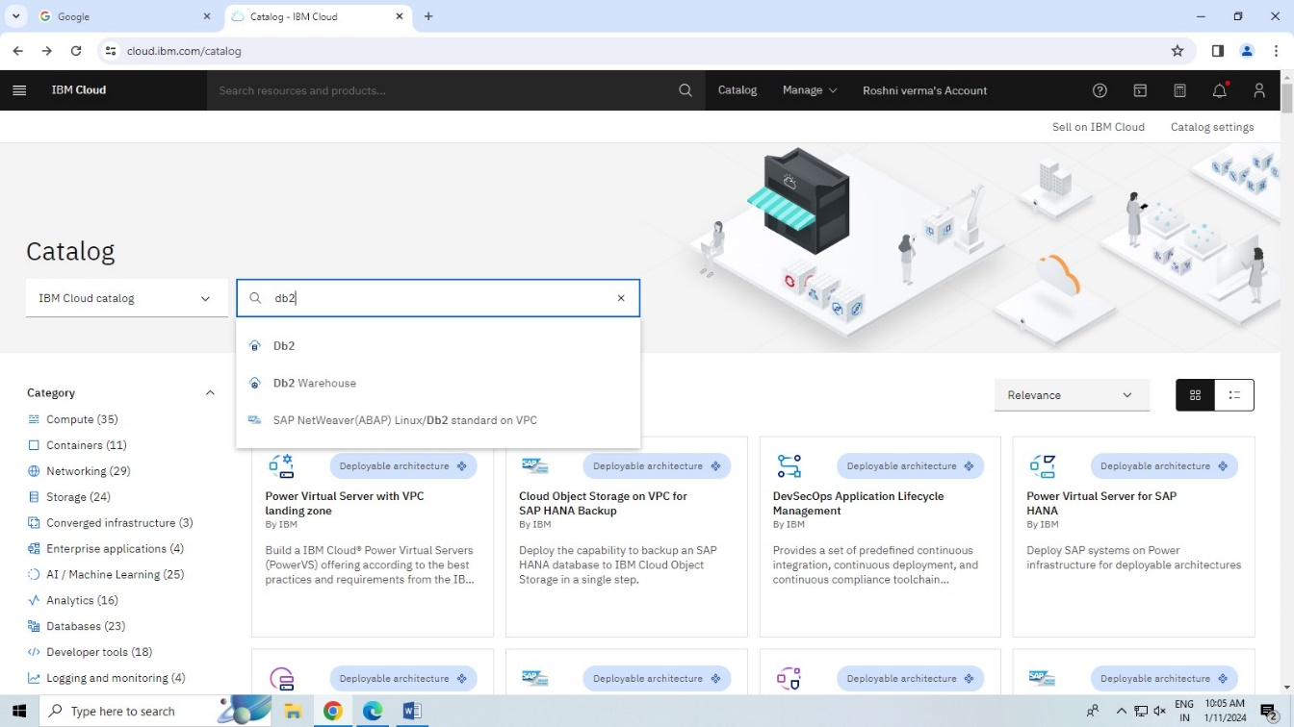

STEP-3 put the service name and choose free lite and create.

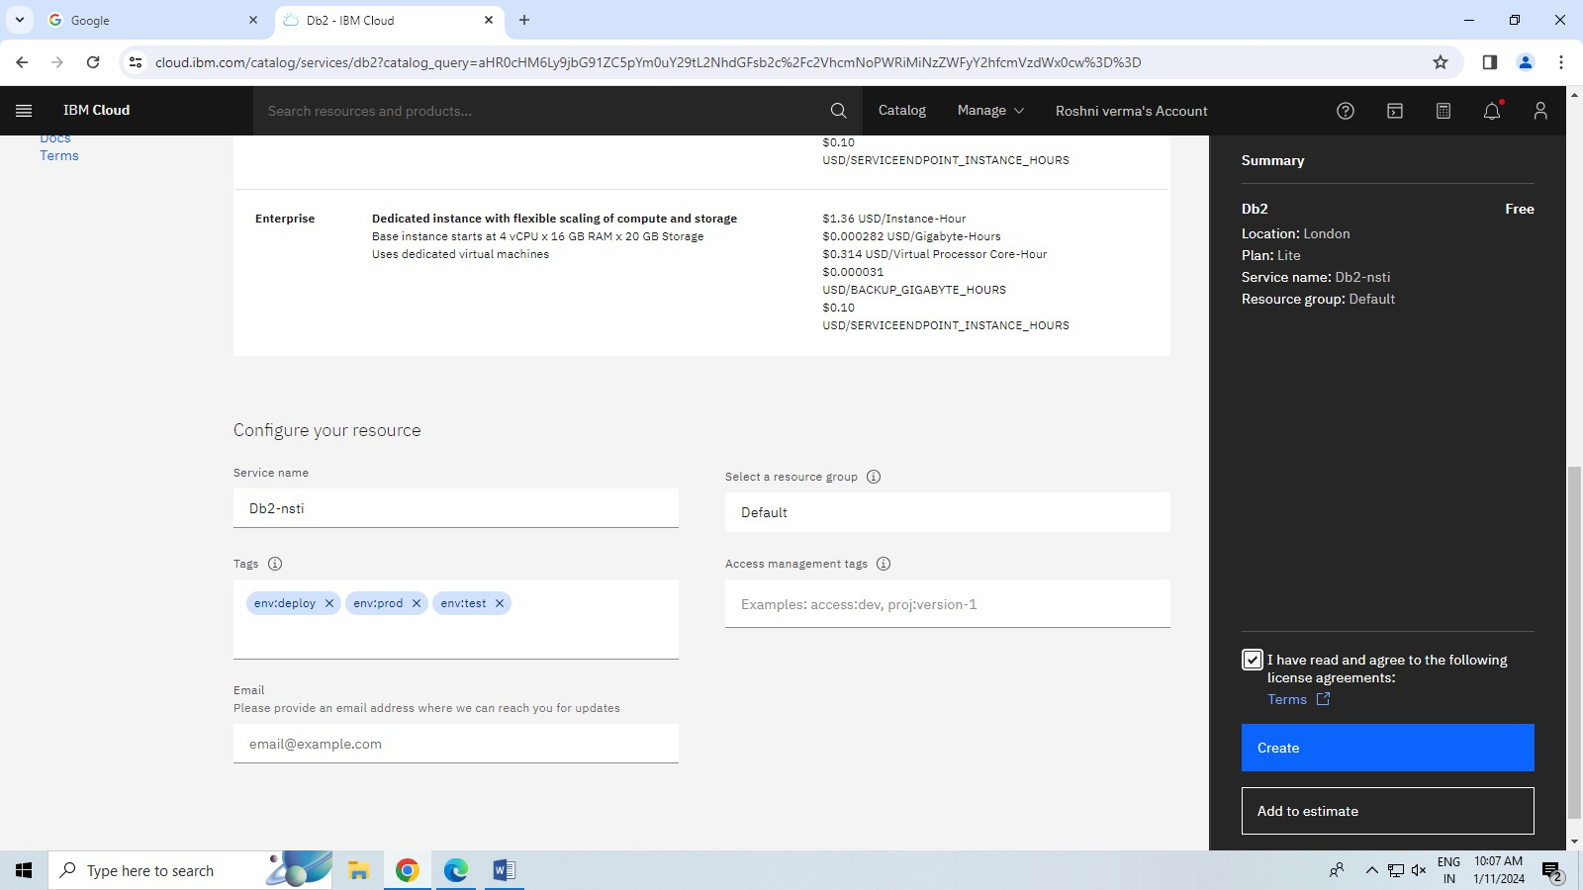

STEP -4 click on go to UI button.

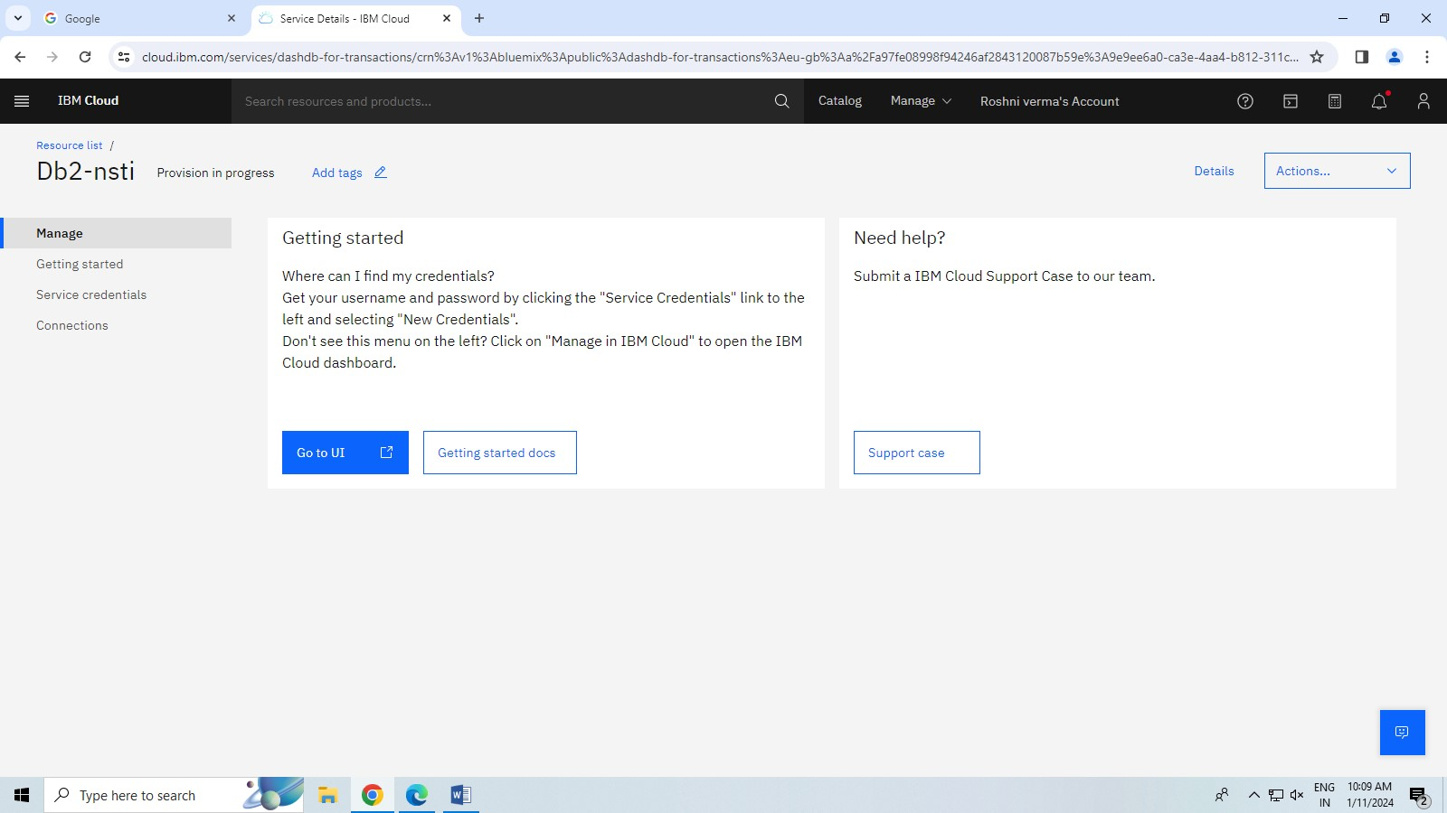

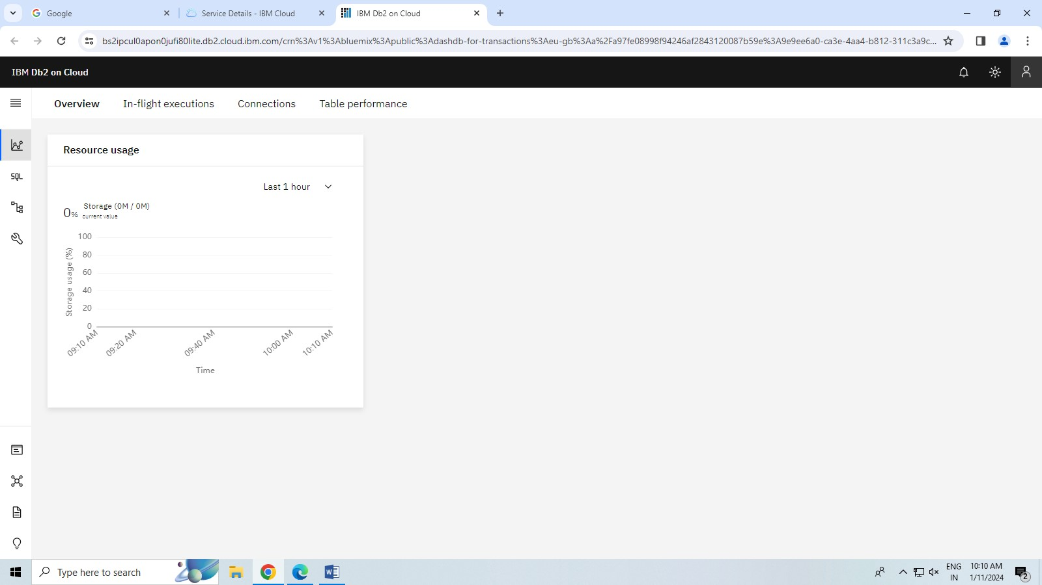

STEP -5 put the csv file in drag file and upload it.

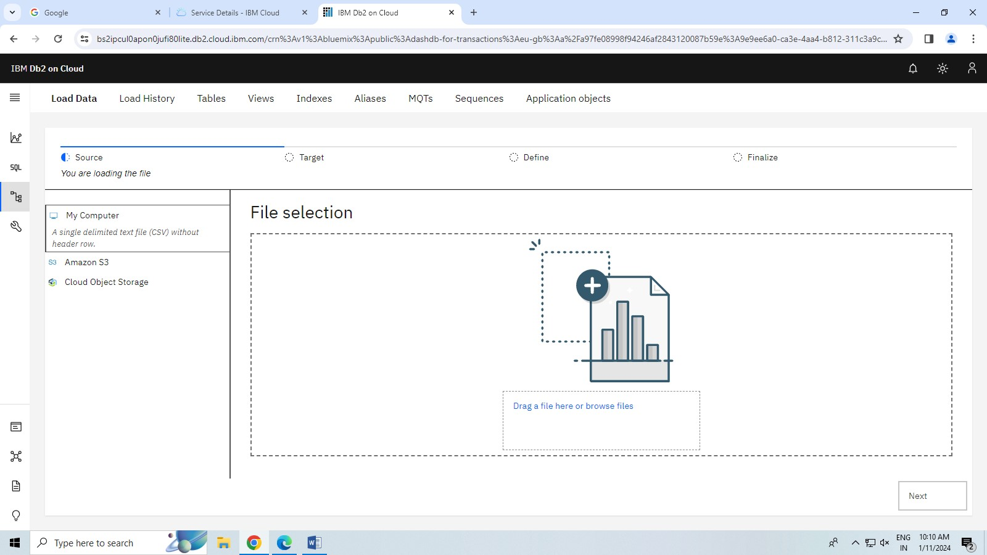

STEP-6 create a table and click to next button.

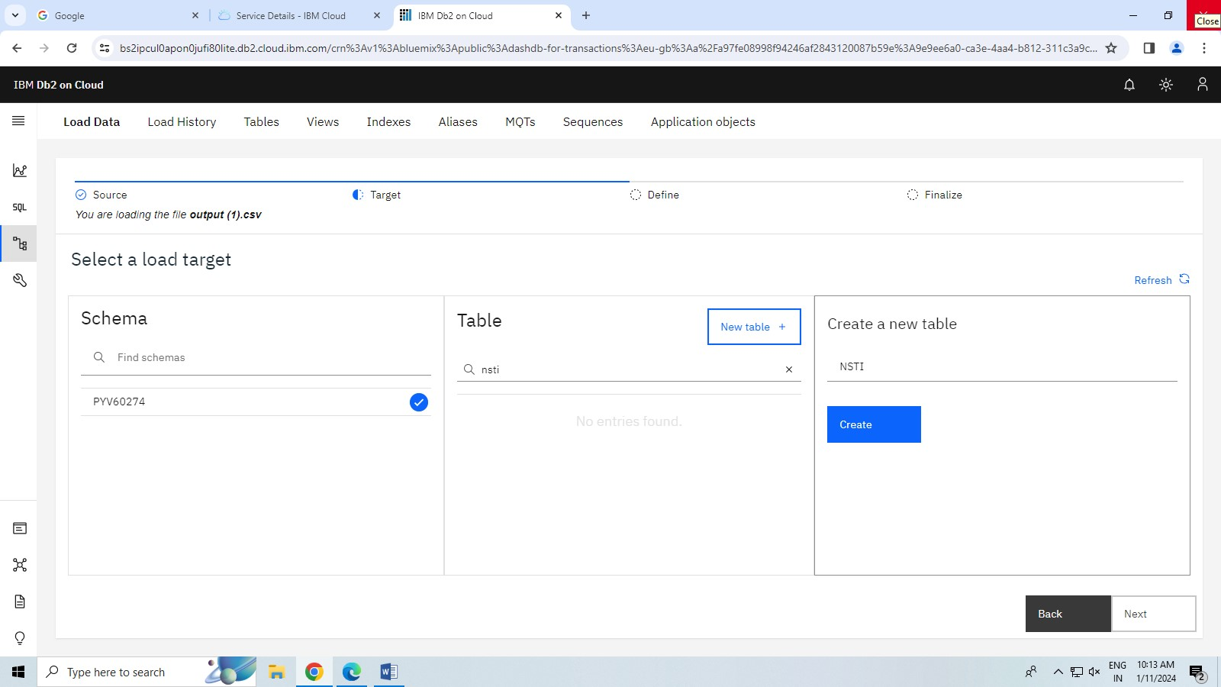

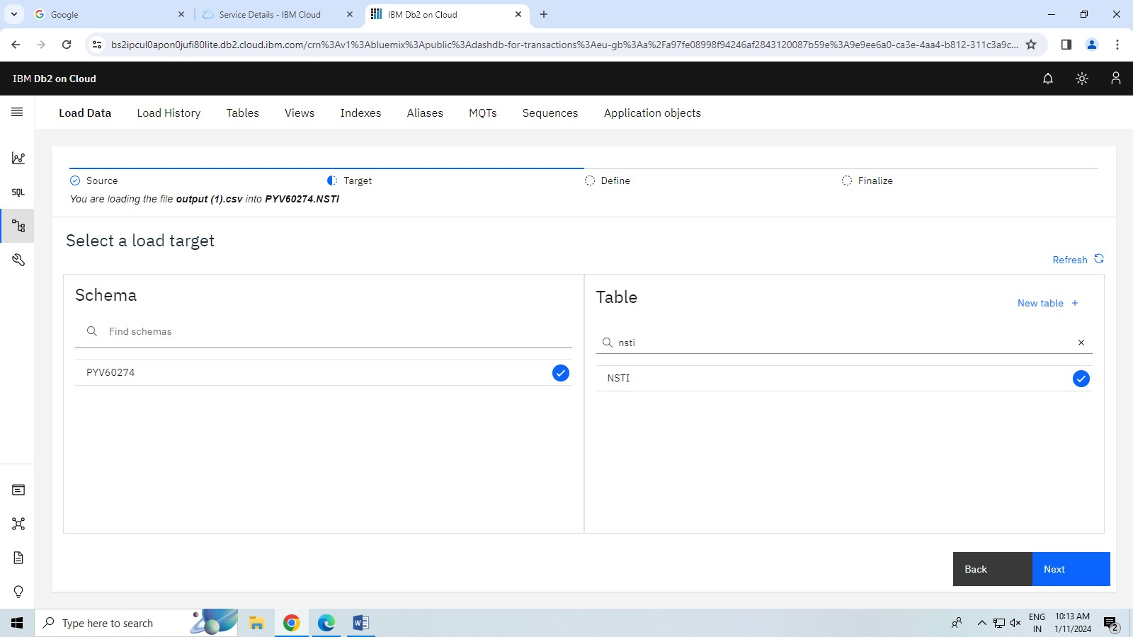

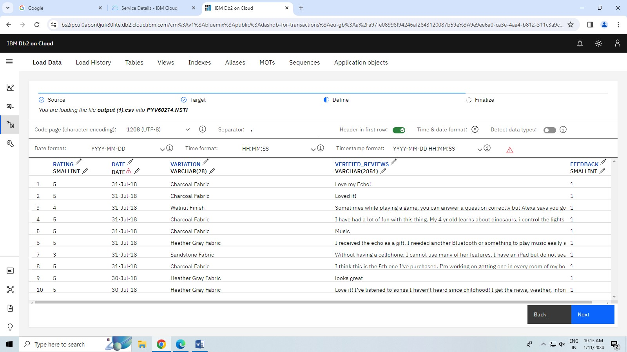

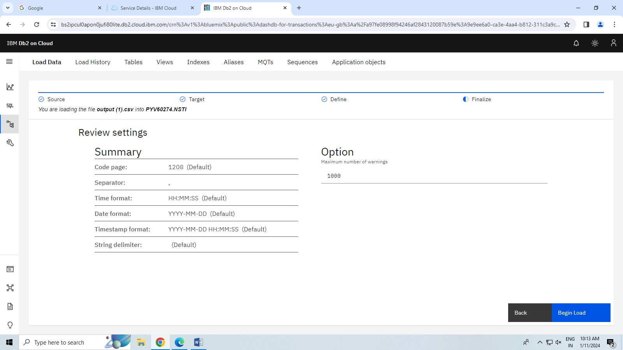

STEP-7 click next button and being loaded.

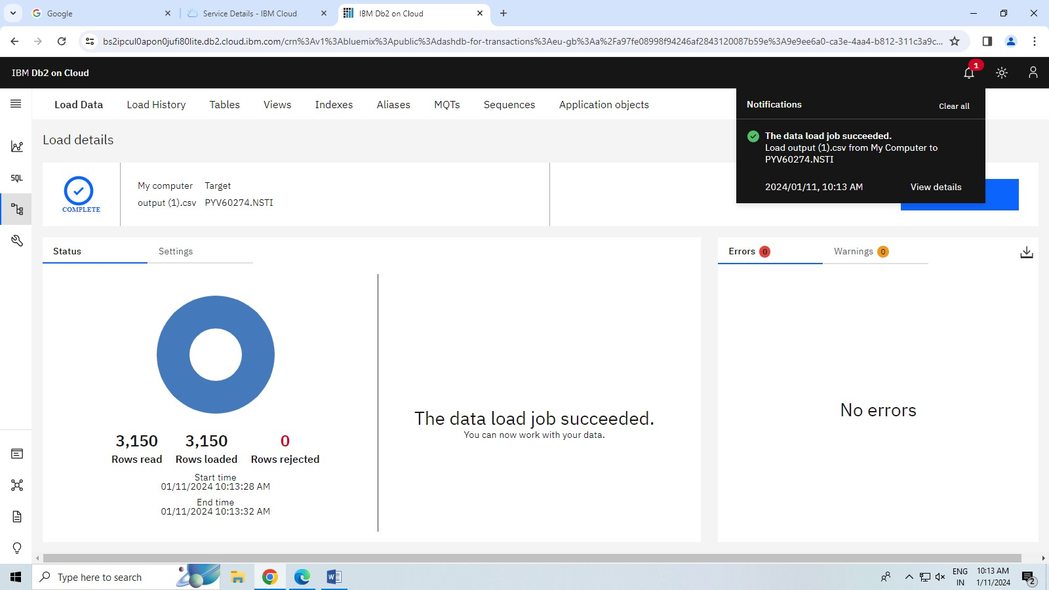

**Question no – 1**

**HARDWARE/SOFTWARE:**

1.COMPUTER/LAPTOP

2.WINDOWS 10/11

3.GOOGLE CROOM

4. INTERNET

5.IBM CLOUD ACCOUNT

**STEP -1** Log in ibm cloud account.

STEP-2 search cloudant in catalog option and choose it.

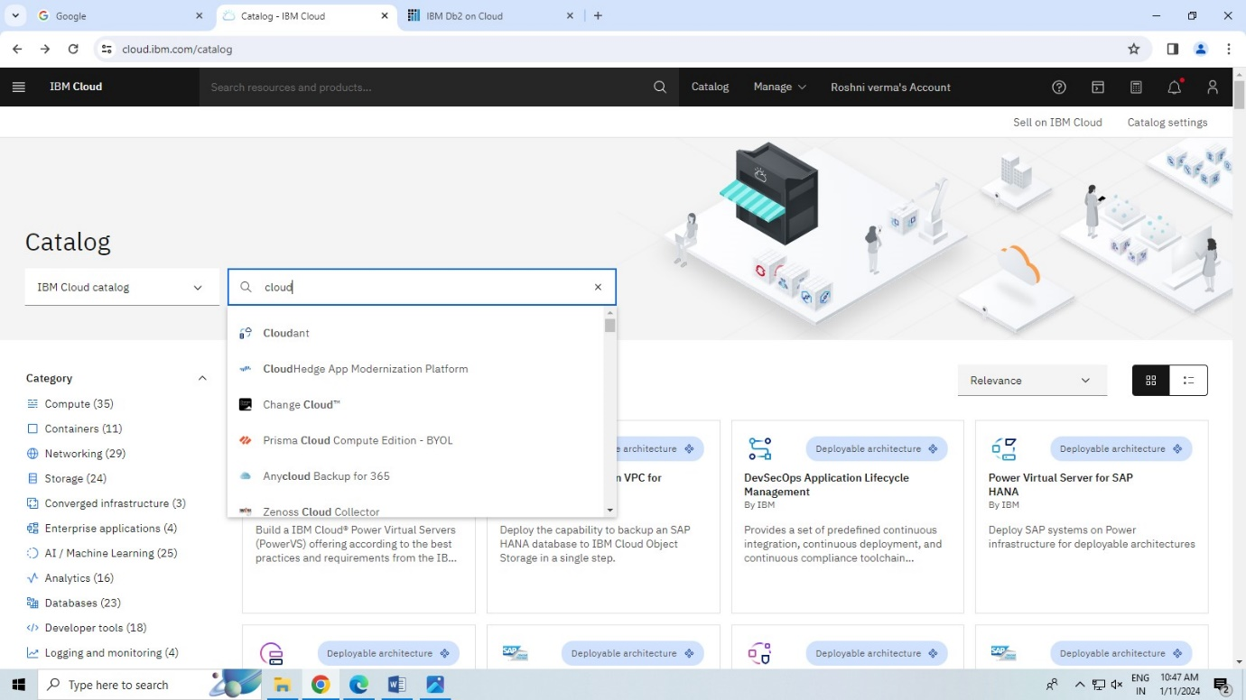

STEP-3 choose a plan and create it.

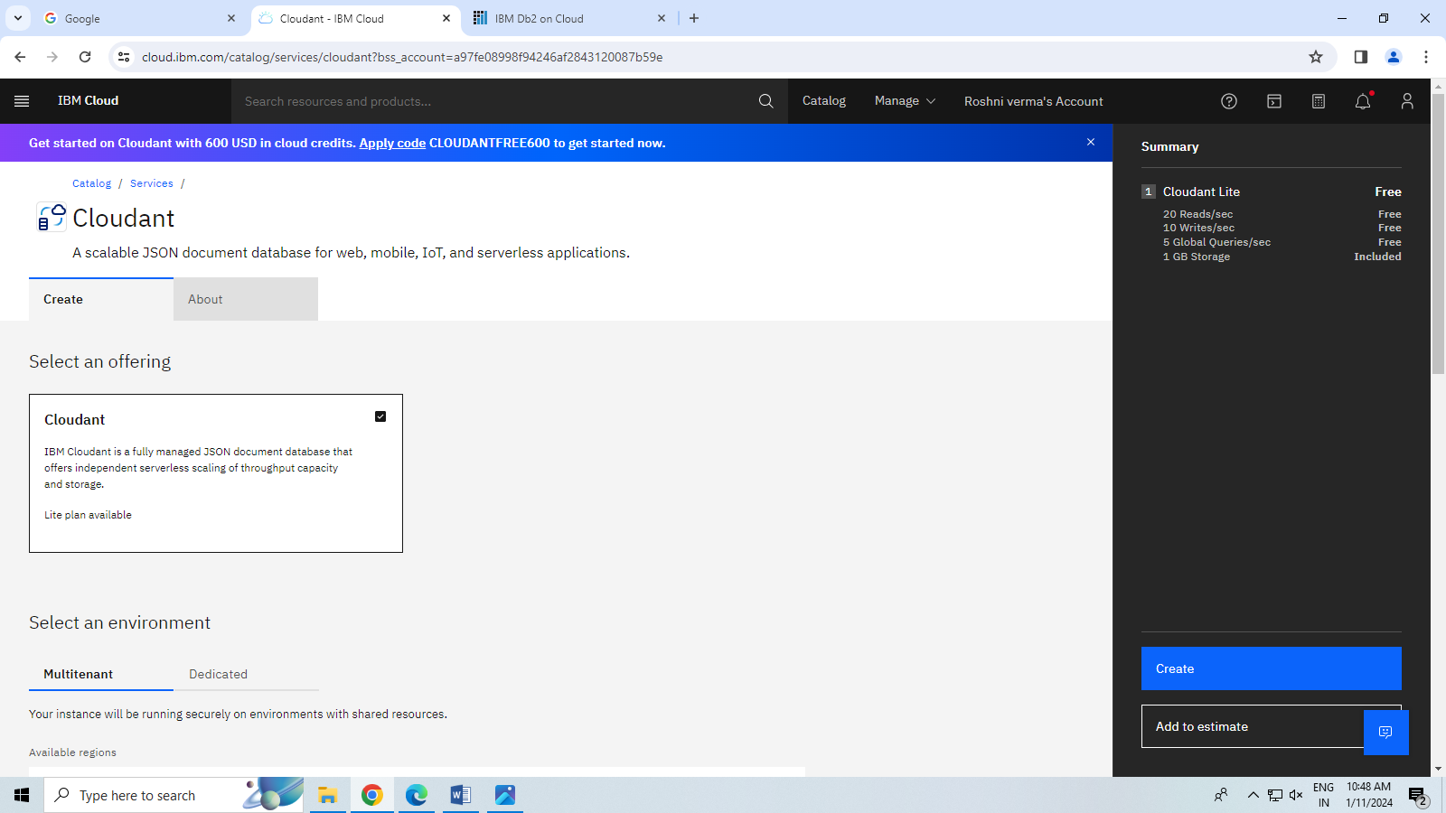

STEP -4 click on launch dashboard.

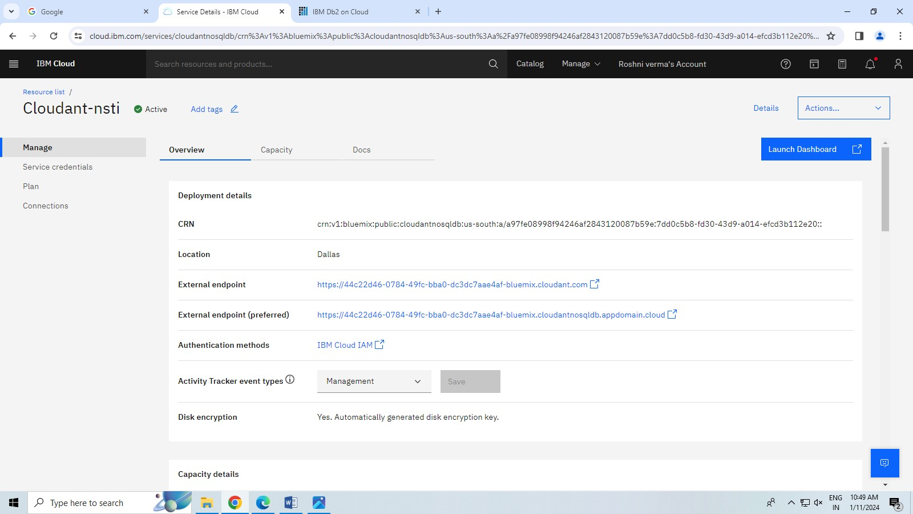

STEP -5 craete a database.

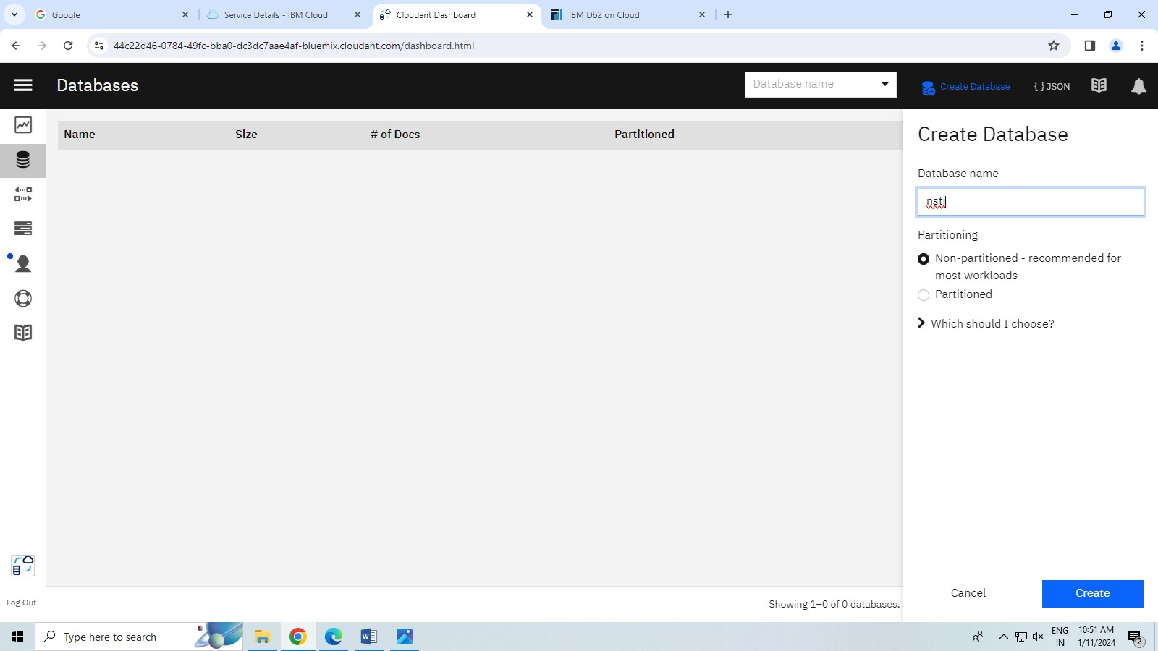

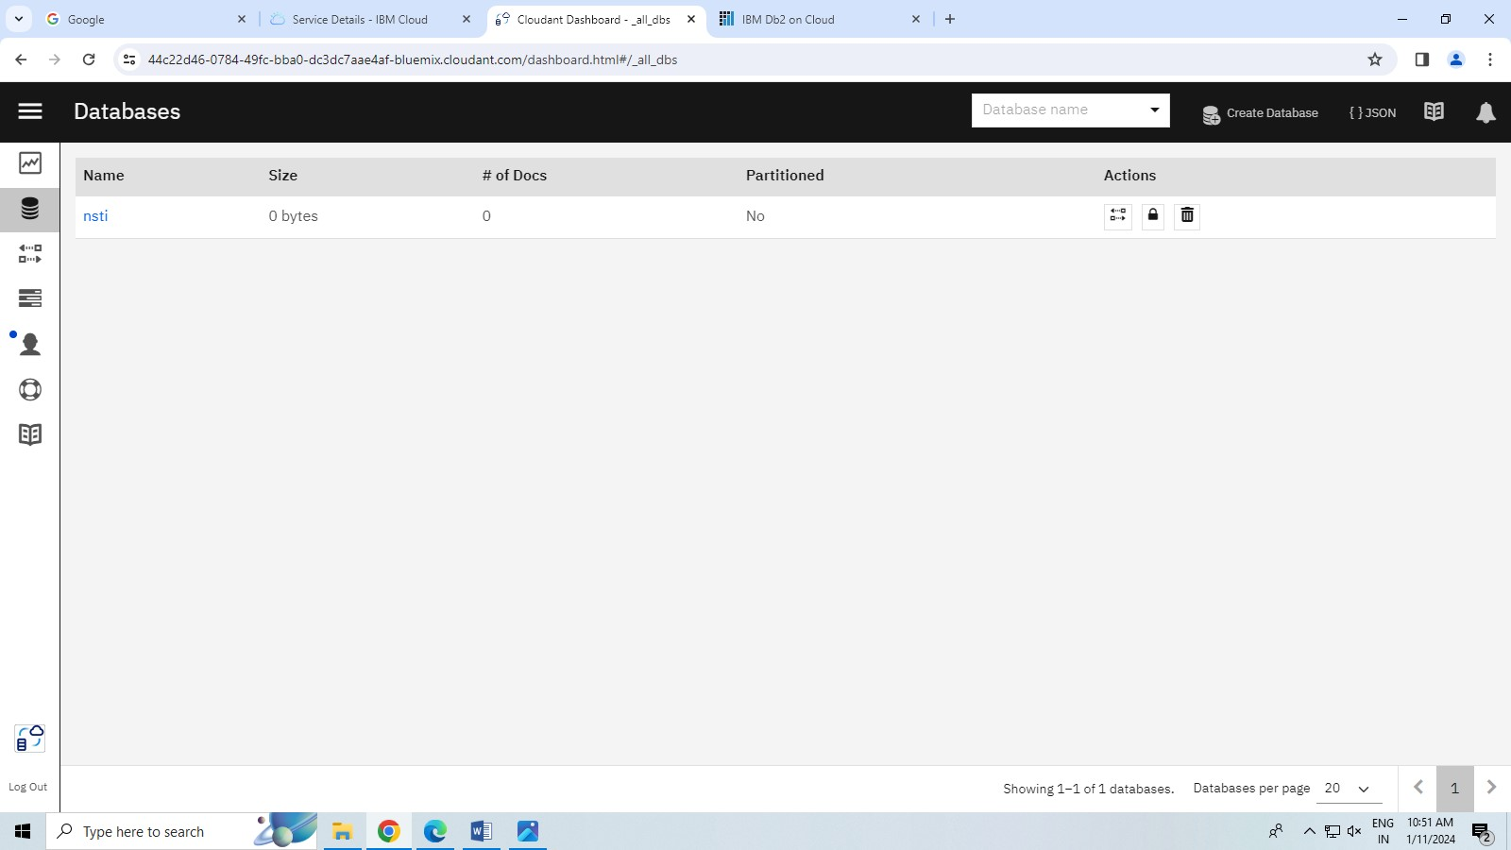

Step-6 create a document ex- name ,email,course put it.

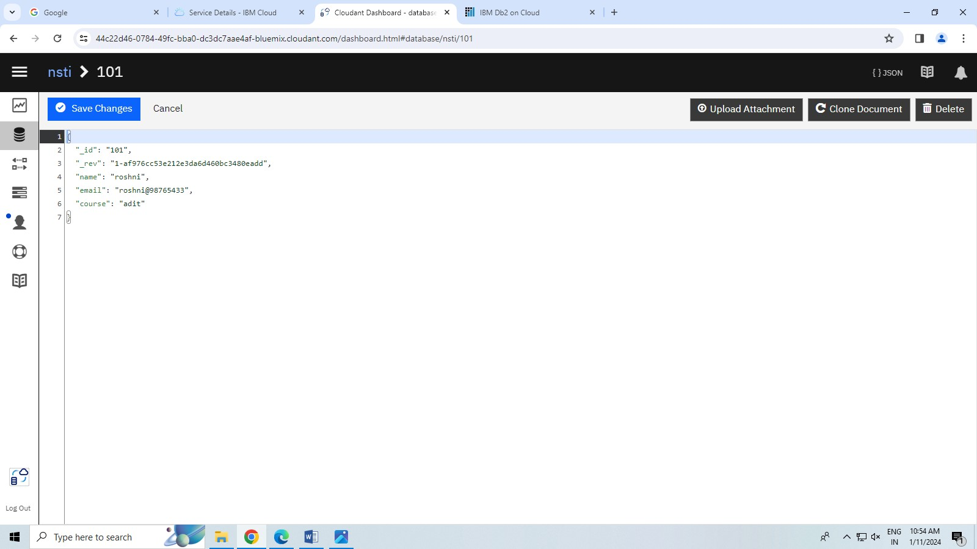

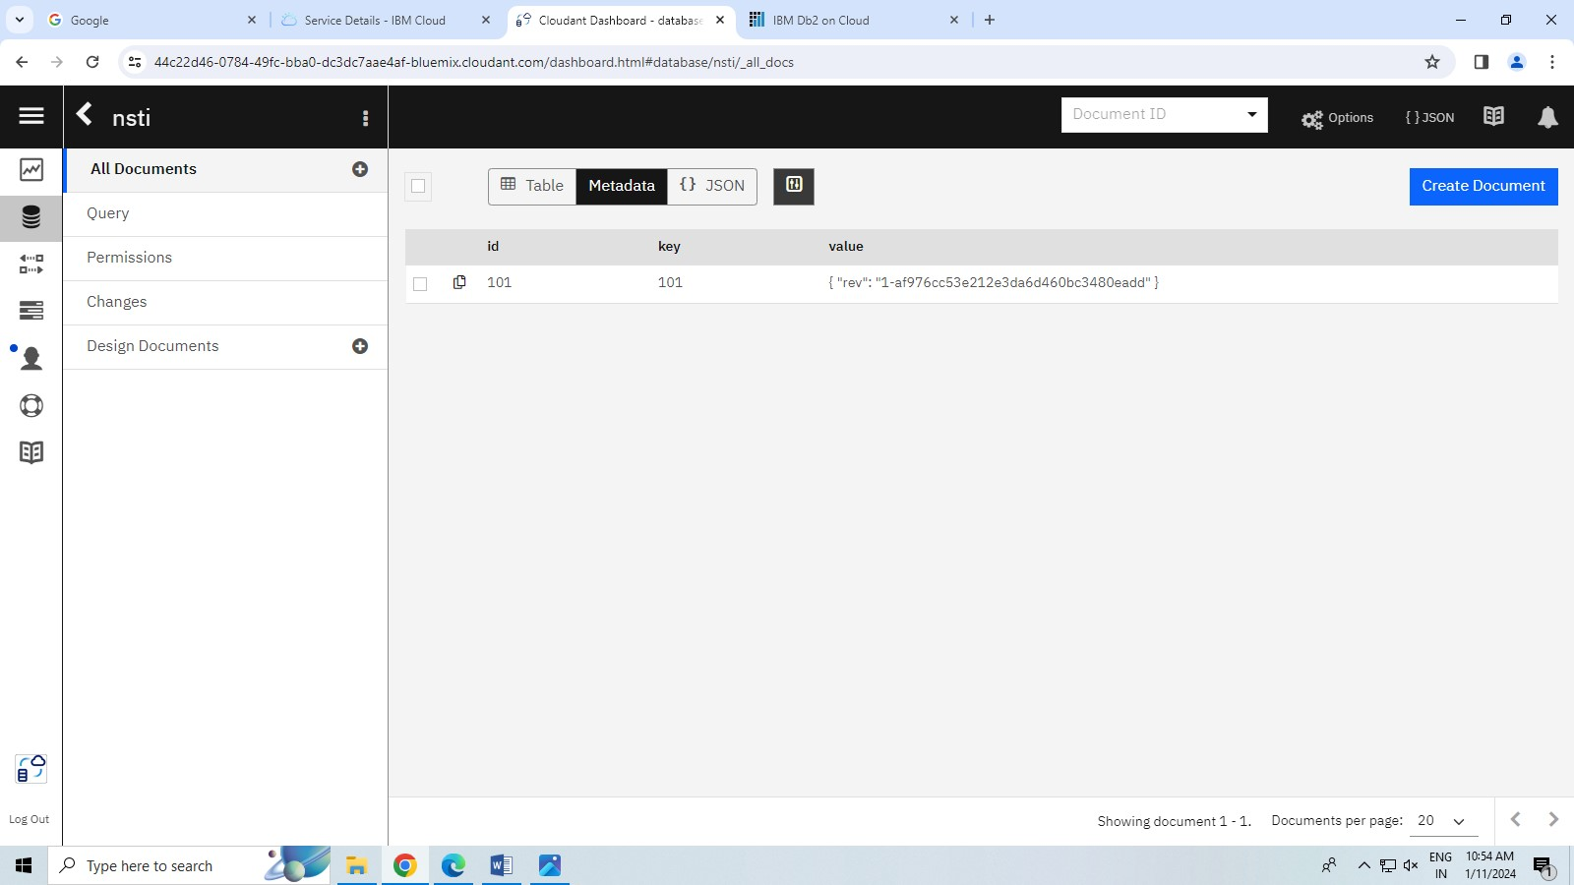

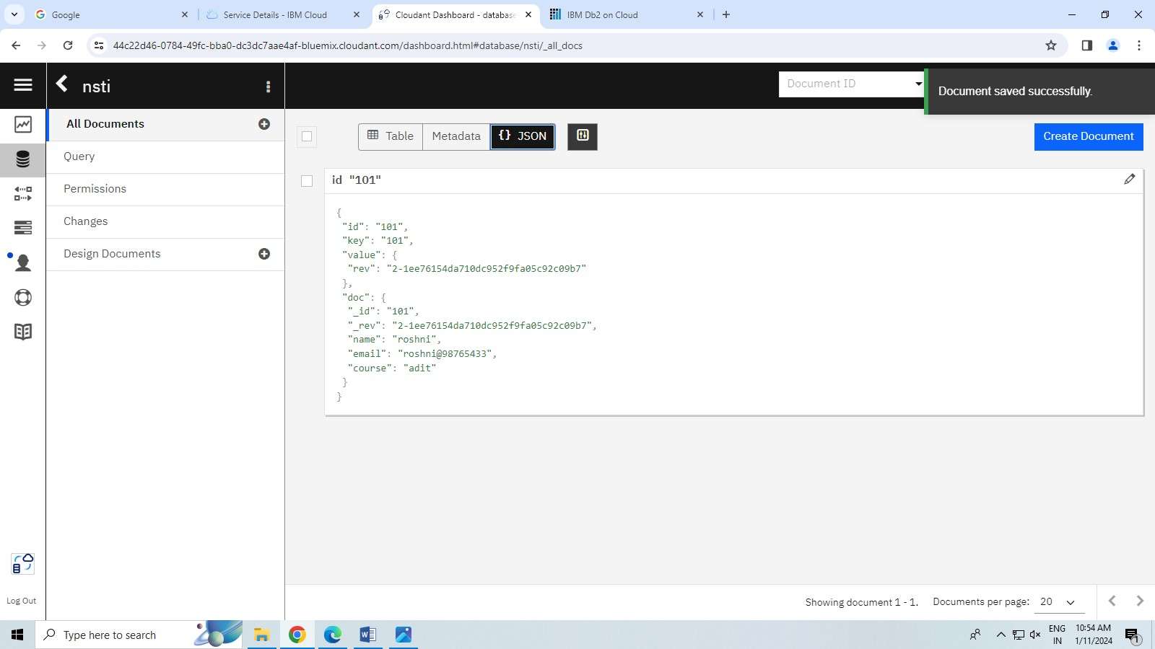

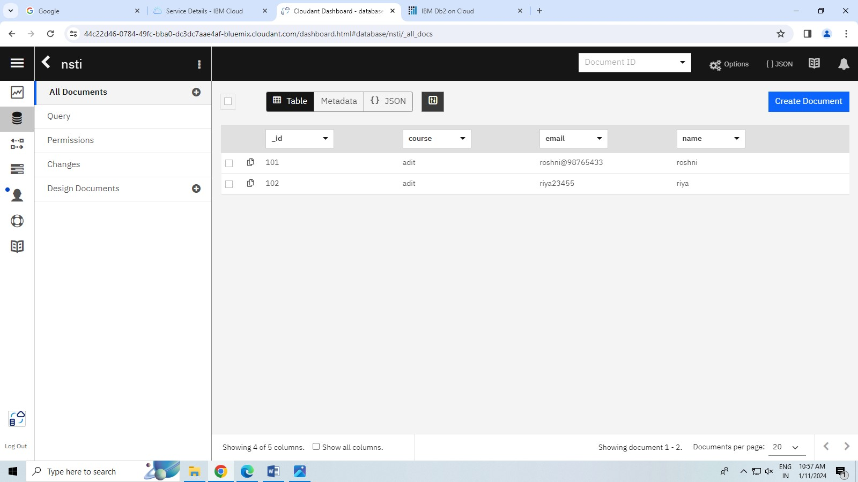

**QUESTION – 3**

**HARDWARE/SOFTWARE:**

1.COMPUTER/LAPTOP

2.WINDOWS 10/11

3.GOOGLE CROOM

4. INTERNET

5.IBM CLOUD ACCOUNT

**STEP -1** Log in ibm cloud account.

STEP-2 search data engine in catalog option and choose it.

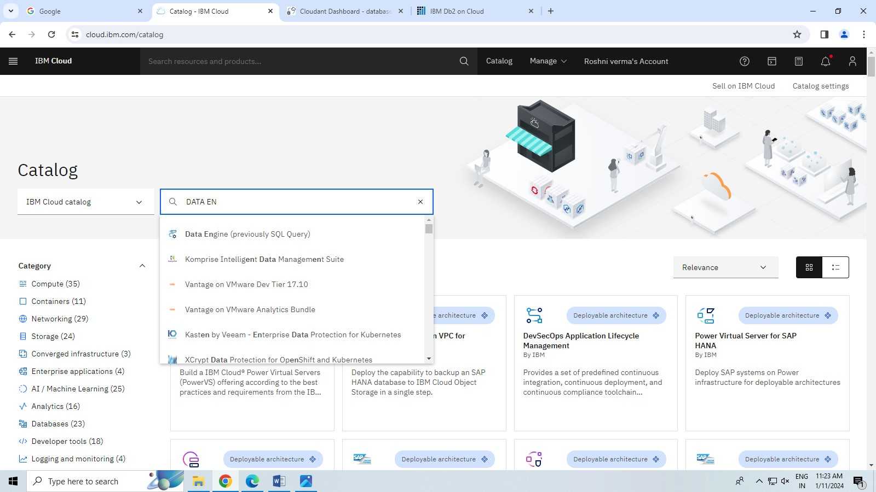

STEP-3 choose data engine and create it.

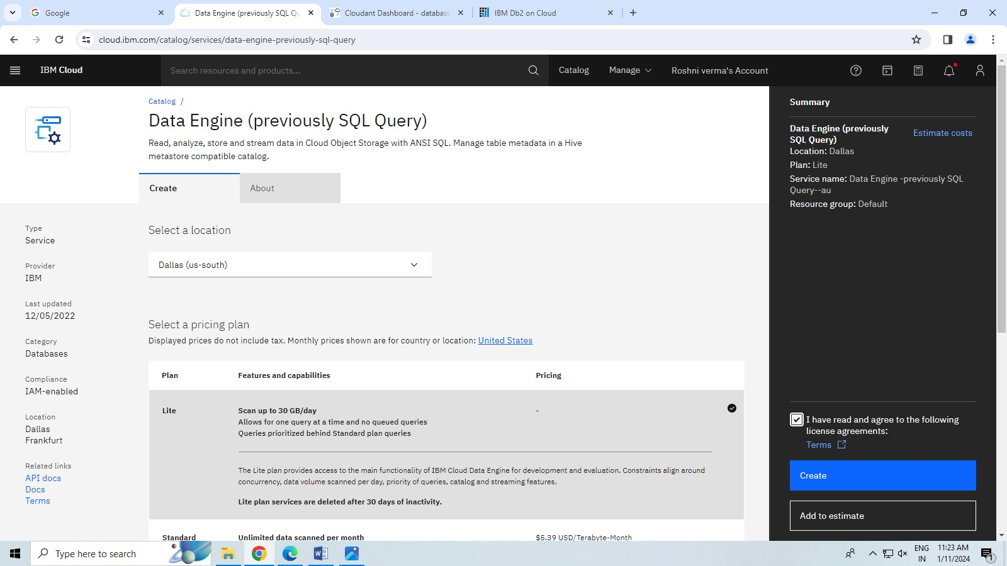

STEP-4 Run it and choose sample and table coloumn.

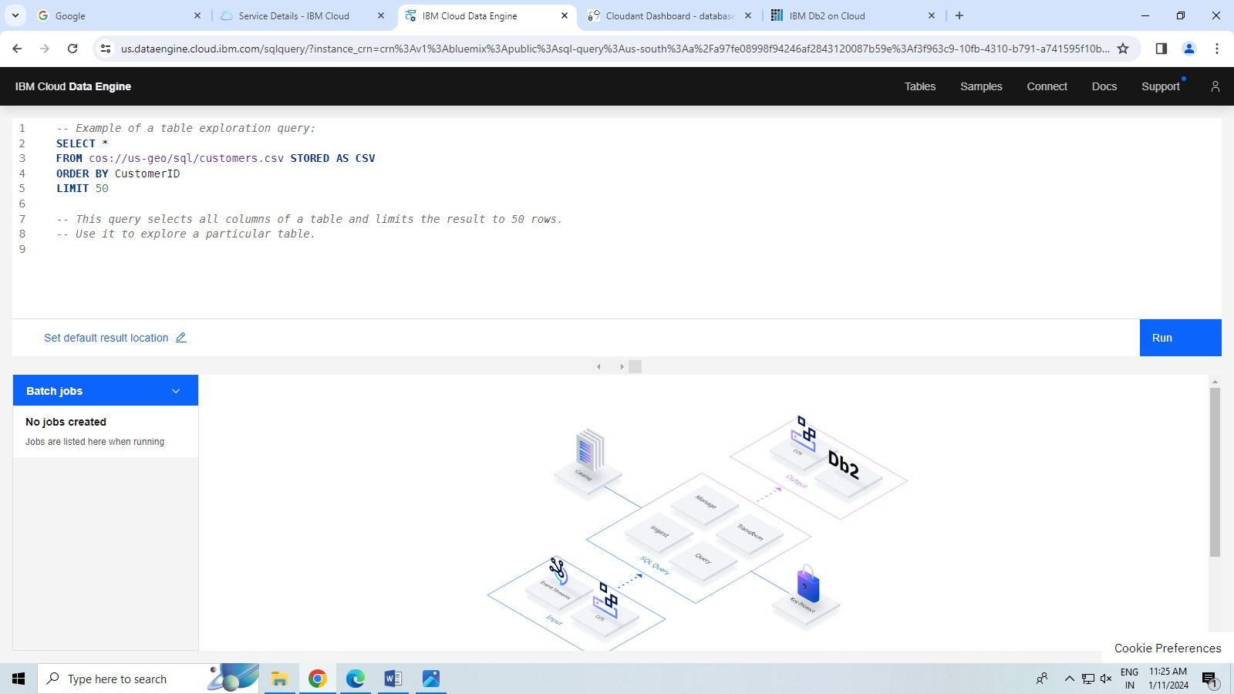

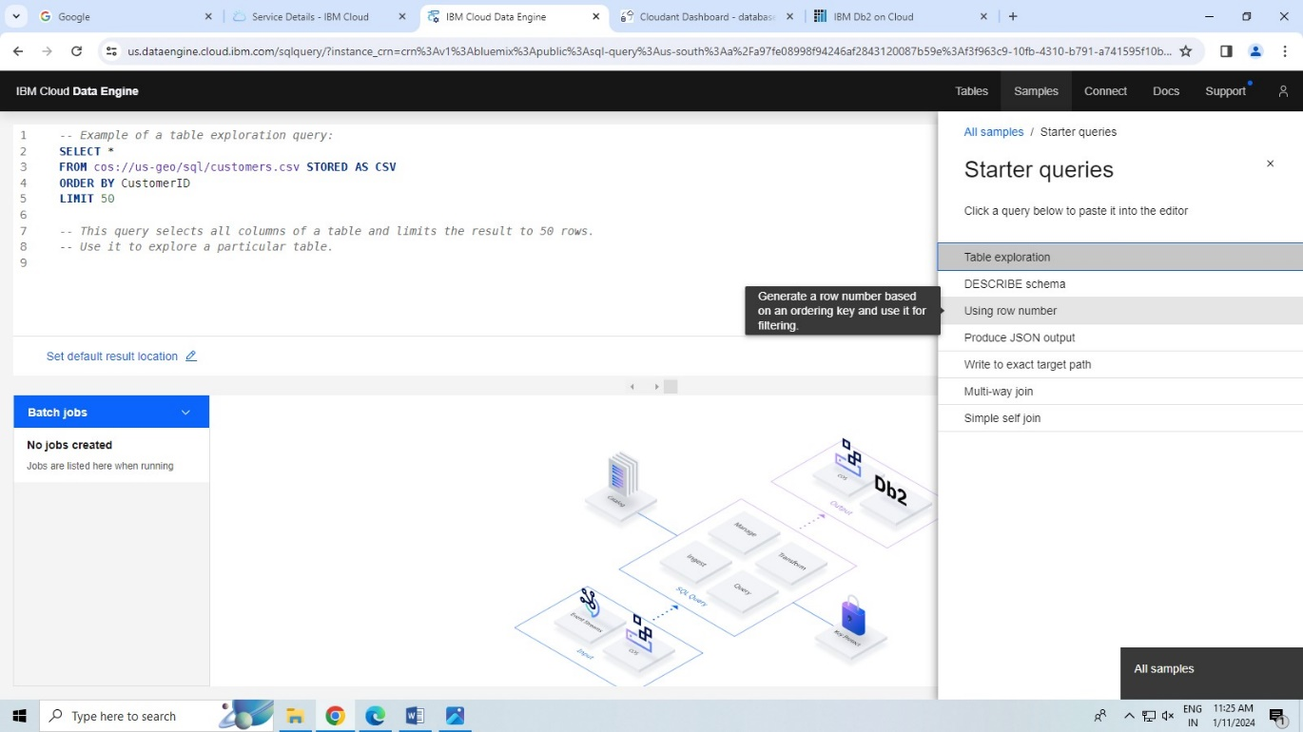

STEP-4 Object storage choose and create.

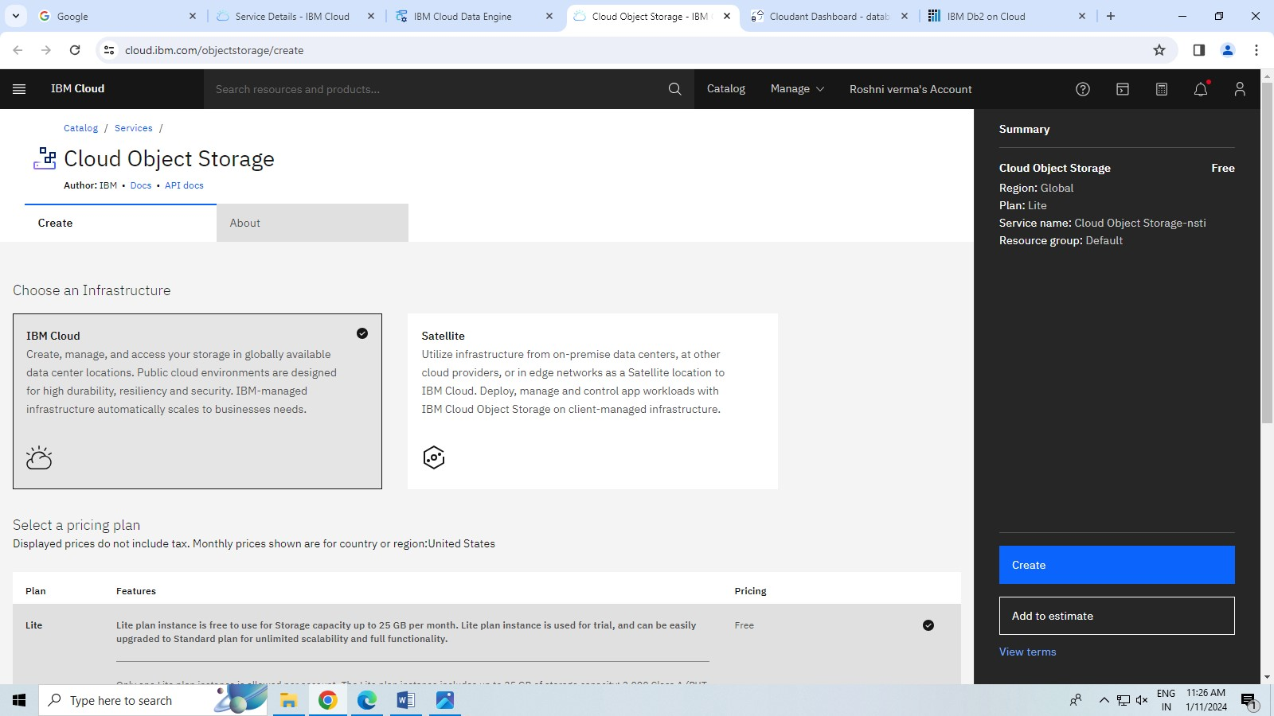

STEP-5 cretae a bucket and credential name add it.

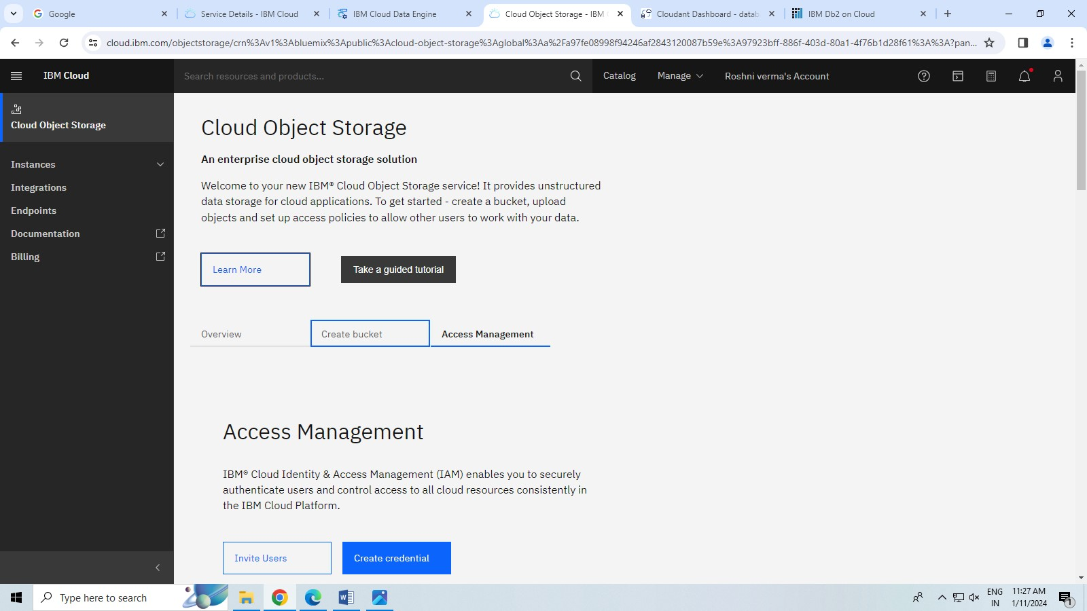

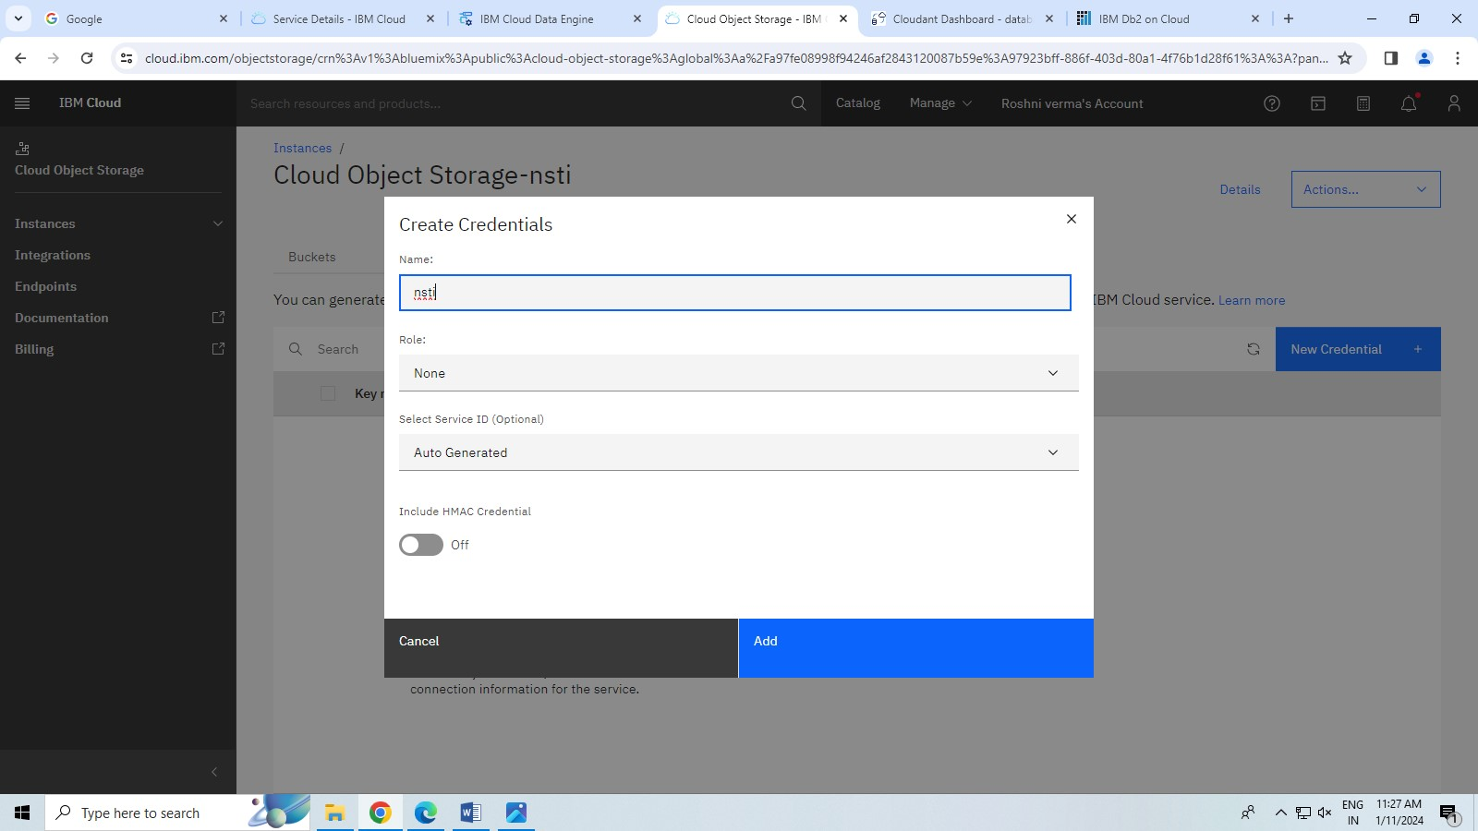

STEP-6 choose a bucket and add bucket name and create it.

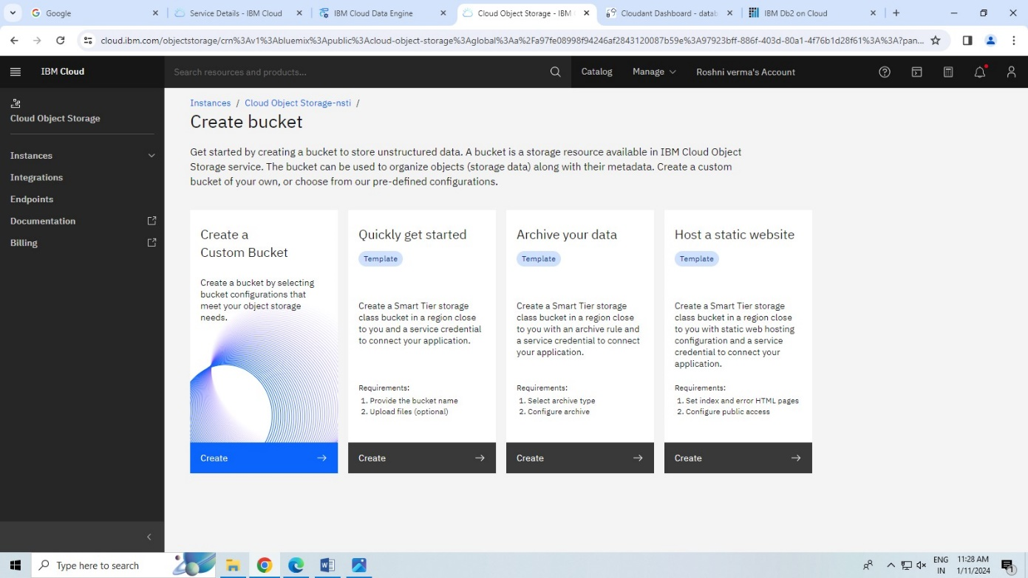

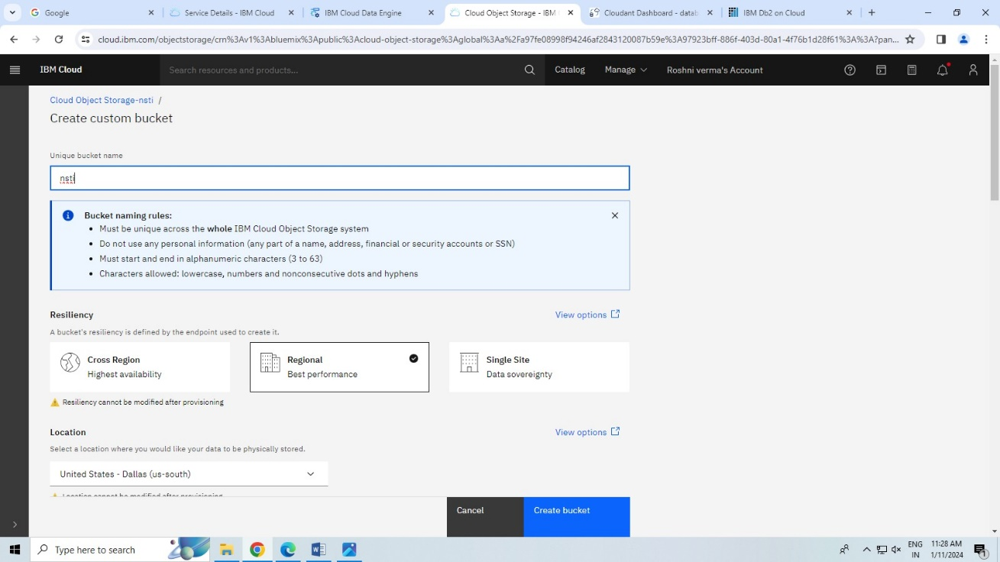

STEP-7 put the name instances and create it .

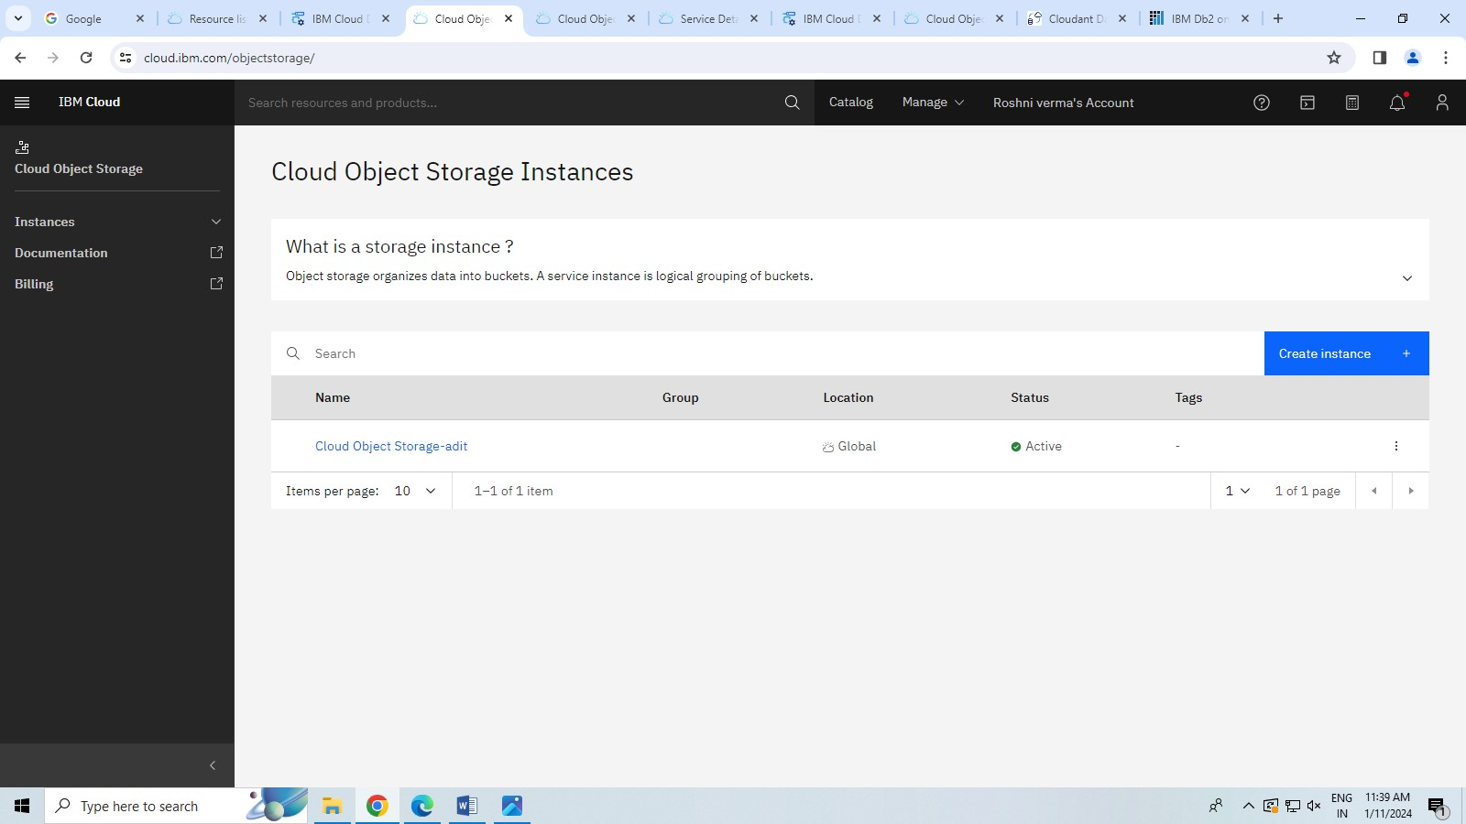

STEP -8 Upload a file and run it.

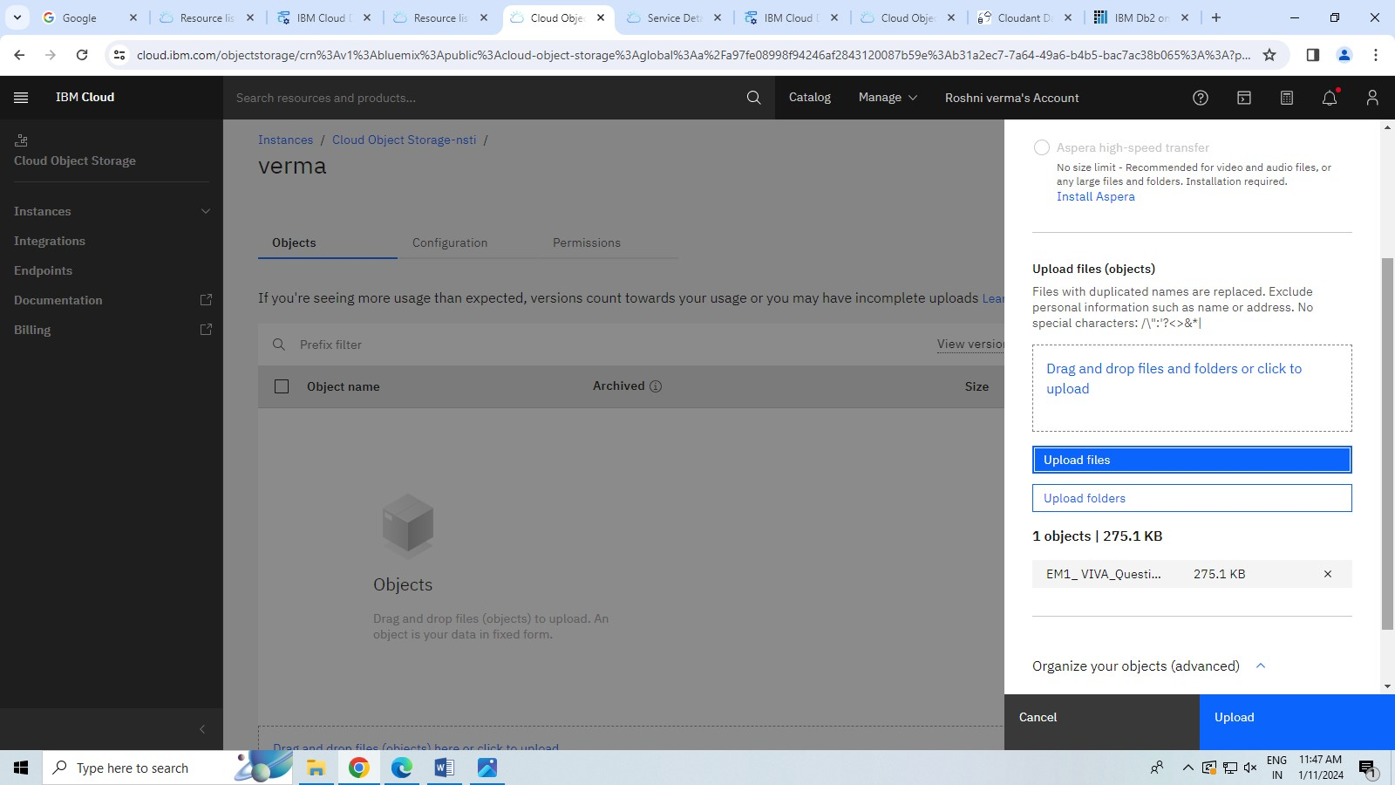

STEP-9 file uploaded successfully.

